### **Joo Sun Lee**

**Heritage: Korean**

**Language Spoken: English, Korean**

**Student Number: s3668699**

**Student Email Address :** s3668699@student.rmit.edu.au

**Your Locale :** Melbourne, Australia

**My Interest in IT**

Throughout most of my life I have had a passion for computers.I learned how to handle computer programming in primary school I remember being fascinated by this machine that seemingly worked by magic. I was the only the one who could solve error codes in computer in my family members long time ago. For me, the most attractive aspect of technology is problem solving. There’s always a logical reason why computers do what they do, and diagnosing problems is both fun and rewarding to me. Also I have a strong interest in IT products. I have used various game consoles, gaming laptops, gaming mouse and a headsets. I have chosen RMIT for my belief that my passion about IT should be more enhanced for my career. Even though there is an unfortunate perception that a career in tech is not a typical choice for a woman. I expect to learn professional programming skills as I am still struggling to utilize Java program and making other computer code. I will need more acknowledge to improve my programming skills.

**Personal Profile**

● The results of an online Myers-Briggs test.

INFP - Introverted iNtuitive Feeling Perceiving

● The results of an online learning style test.

Visual learner

learn by reading or seeing pictures. You understand and remember things by sight. You can picture what you are learning in your head, and you learn best by using methods that are primarily visual. You like to see what you are learning. As a visual learner, you are usually neat and clean. You often close your eyes to visualize or remember something, and you will find something to watch if you become bored. You may have difficulty with spoken directions and may be easily distracted by sounds. You are attracted to color and to spoken language (like stories) that is rich in imagery.

-Have eyesight checked on a regular basis.

-Try to visualize things that you hear or things that are read to you.

-Color code things.

● The results of Big Five Personality

-Auditory: 20% -Visual: 45% -Tactile: 35%

My score for openness was high, at 81%.

Openness describes a person’s tendency to think in abstract, complex ways. High scorers tend to be creative, adventurous, and intellectual. They enjoy playing with ideas and discovering novel experiences. Low scorers tend to be practical, conventional, and focused on the concrete. They tend to avoid the unknown and follow traditional ways.

My score for conscientiousness was low, at 35%.

I am low in Conscientiousness, you may be somewhat impulsive and have problems resisting distraction and temptation. I prefer to be spontaneous and flexible rather than plan things out. You are probably disorganized in some, or even many, areas of your life.

My score for Agreeableness was high, at 75%.

I am high in agreeableness, I probably think of yourself as a kind, compassionate person. You sympathize easily with others and want to get along with people.

My score for Neuroticism was moderate, at 62.5%.

My score indicates that I am fairly typical in my tendency to experience negative emotions. I probably feel sadness, worry, anger, and guilt about as much as the average person. You are neither overly reactive, nor especially resistant to the stresses of life.

-

Based on this result, I can also lead if I have to, making decisions independently for the collective group. I am good at picking out faults and strengths in both design and reporting. My interests relating to this project would be the user side of things, where I expect to create a great experience for the user, this includes design, ease of use, speed, etc. I am a good listener and negotiator in group discussion.

My weakest point in this project is definitely programming and making network as Also I am someone who likes to gain lots of new experiences and work with new people, so I tend to say yes to too many projects, and that’s created some issues for me in the past I will attempt to communicate with group for help at this point.I I expect to see myself work on the design aspect of this project. I will endeavour my duty in group work to contribute group work with my creative design suggestions. Also i will do my best to achieve best mark i could get

**My IDEAL JOB - Mobile Developer (Android)**

**Link** <https://www.seek.com.au/job/35751645?type=standard&userqueryid=42f3992768f79aed95da57b07c79fcbb-8232608>

**Snapshot**

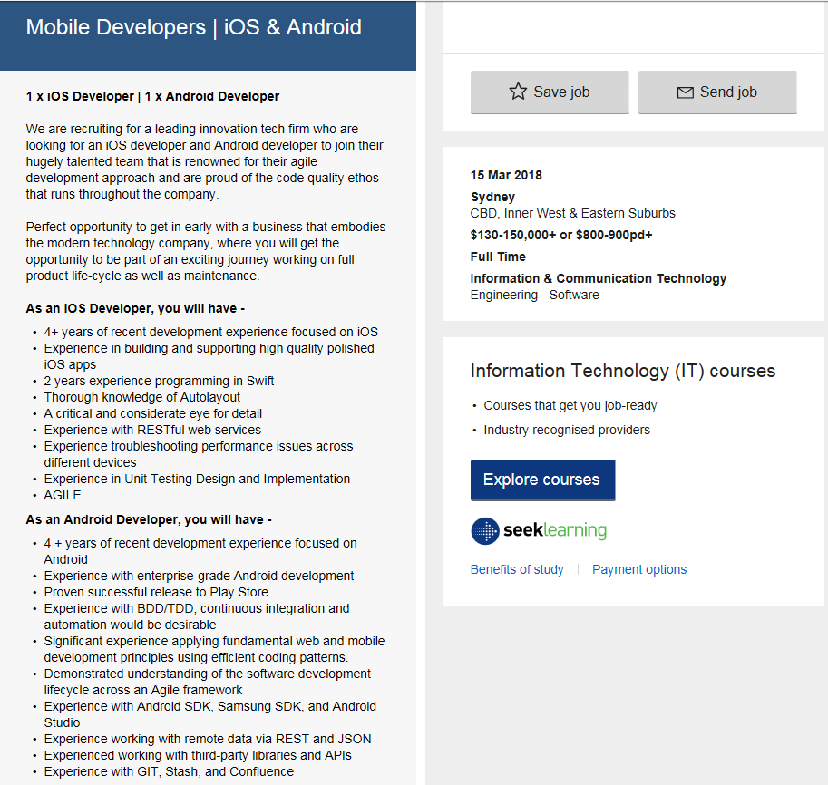

position, and particularly what makes this position appealing to you.

Being an Android developer is generally an amusing experience. I could work for a big organization or as an individual developer selling apps on the Play Store, there are a ton of benefits that come with the territory and that make this an excellent career choice.

skills, qualifications and experience required for this for the position.

1. Java experience

Java is the language that underpins all Android development.For those who have gained most of their coding experience in languages  [JavaScript](https://generalassemb.ly/education/javascript-development) and Ruby, there can be a learning curve when picking up Java for the first time. most positions are for native development using Java and Android Studio or Eclipse.

2. Understanding of XML

XML was made as a standard way to data for internet-based applications. It is a structured markup language, sharing many features in common with HTML. In the Android world, developers use XML to create layouts that serve as the foundational UI definition for Android applications. Following the informations, Developers can write Java code that modifies layout elements. In the same way that web developers use JavaScript to modify the elements in their website.

3. Android SDK

SDK stands for Software Development Kit, which, though it may conjure up images of a briefcase full of spy tools, is a name for a set of pre-packaged code. The Android SDKs are modules of Java code that give developers access to device functions like the camera and accelerometer. New Android developers spend much of their time discovering how the various SDKs for Android can be pieced together in different ways to put together an application.

4. Android Studio

The integrated development environment (IDE) of choice for Android developers is called Android Studio. Android Studio is built on top of the well-respected IntelliJ IDE, and it support for many of the most common Android SDKs. Android Studio also features many of the capabilities developers expect of a full-featured IDE. Code completion helps make auto-complete suggestions. Android Studio is a must have for the Android developer.

My plan

I do not have specific plan currently. I will apply one of IT course, Mobile Application Development in semester 2 in RMIT. I have to learn this skill through online resources and tutorials,

**Project Idea**

This project will form of both a website and android mobile application, which operates as a unique marketplace for clothings. The purpose of this marketplace is to create a huge space where multiple third-parties can both sell and purchase cloths.

The reasons for beginning this project include, lack of safe and secure cloth sales market in Australia, my interest in cloths, and to further skills in website and application development. Australia compared to other countries has little to no option for a dedicated clothing marketplace, and all the marketplaces today. Lack of reliability in relation to quality and expected cloths outcome, I take this as a problem and thus decided to create this website and application that better exemplifies a great clothing marketplace. I have a lack of knowledge in this area and thus have to learn independently about web and application programming.

This platform would utilize a bidding system in order to sell these various types of cloths, this will affect that a user does not have to guess the value of their products, also it will bring negotiations, that customers can simply suggest that a minimum price and see what others think about how worth they are. For example for selling system, users are required to provide a picture/description of their products and a minimum price and they can have their shoes on the marketplace in an instant. For buying, a consumer only has to make a bid and wait until the selected time is over before purchasing by entering their selected payment option. An account rating systems is put in place to ensure buyer security where shoes sold are always kept to a high and honest quality. There is also a separate forumand hub system implemented where people can discuss about various topics through creating posts and commenting on postings. An internal chat system is also in place so that you can message either a buyer or seller via Collaborative Workspaces such as facebook

**Android Studio** tools need for the Development software of Android apps,

Short Description: The official Integrated Development Environment (IDE) for apps on the Android platform.

**Adobe Dreamweaver**: Software to build the website

Short description: Adobes GUI based website development program.

Rationale: Well known, easy to use with minimal learning curve.

Specific version: 2017 Version

URL: <http://www.adobe.com/au/products/dreamweaver.html>

## **Facebook Messenger** Website: www.facebook.com Description: This is a more informal collaboration tool. Due to its nature, it is used for low-level reminders and short communications. Trello will be the main site where we officially communicate. It has a web-based site and a mobile app.

I should develop current skills for projects. I have never programmed a website or application before, In order to this I have to learn this skill through online resources and tutorials, Then I could have an one step forward to be an application developers. Also learning design concepts and how to create a product that caters the user will be a new experience, this will be done through learning the practices and standards for creating a website and application.

I have a good sight for fashion marketplace and art development as I have studied visual art and fashion industries. I have various professional design skills With my customer’s point of view, I am interested in collecting nice clothes and through social network such as Instagram etc. or any kind of market place as I can read latest trends.